
Symbiosis Institute of Technology, Pune
CSE- Academic Year 2026-27
Java Programming – Lab Batch 2025-29
Lab Assignment No.: 4
Name of Student | Akshit Gawade
PRN No. | 25070122029
Batch | 2025-2029
Class | A1
Academic Year & Semester | Second Year  Semester III
Date of Submission | 11/7/26
Title of Assignment: | Develop a Java application demonstrating the use of wrapper classes for conversion  between primitive data types and objects, and performing basic operations on wrapped values.
Problem Statement  Learning Objectives | Develop a Java application demonstrating the use of wrapper classes for conversion between primitive data types and objects, and performing basic operations on wrapped values.  To perform conversion between primitive data types and wrapper objects using Java wrapper classes.
Theory | Wrapper classes are predefined classes that encapsulate primitive data types into objects. Java provides wrapper classes such as Integer, Double, Character, and Boolean for every primitive type. They support autoboxing, unboxing, parsing, and conversion methods. Wrapper classes are widely used in Java Collections Framework and when object representation of primitive values is required.
Program Code | 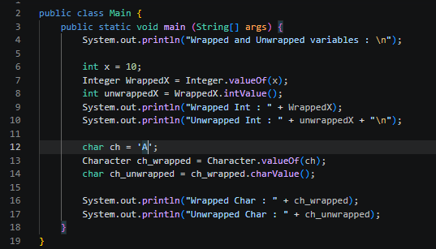
Output Screenshots | 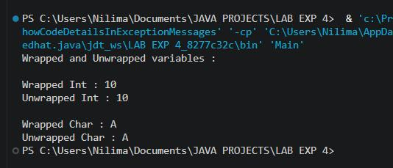
Exercise Qns | Q1. Create a program to convert student marks from String format to Integer and calculate total marks.  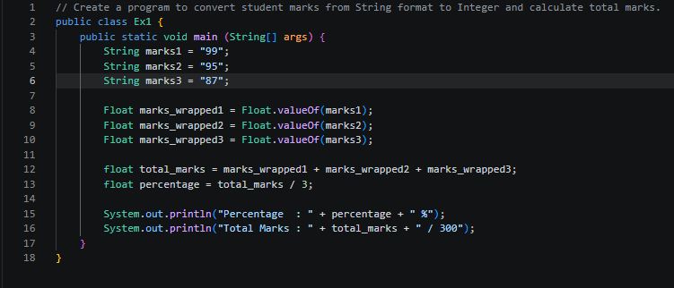  Q2. Develop an Employee Payroll System that accepts employee IDs, basic salary, and bonus amounts from the user. Convert the entered values into wrapper objects and perform validation operations to ensure valid salary values before calculating the net salary.  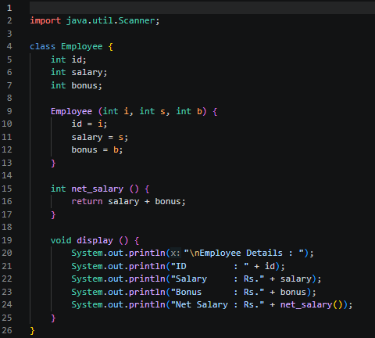  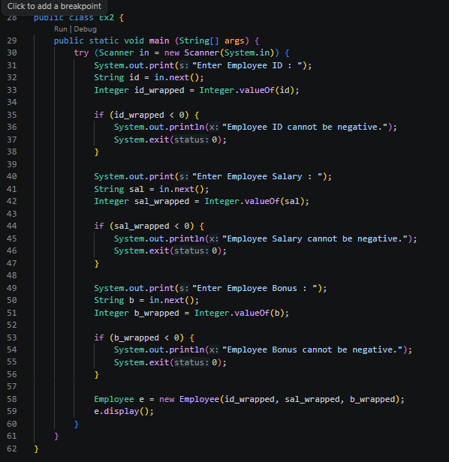
Output Screenshots | Qn1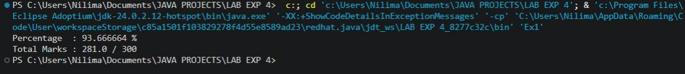  Qn 2  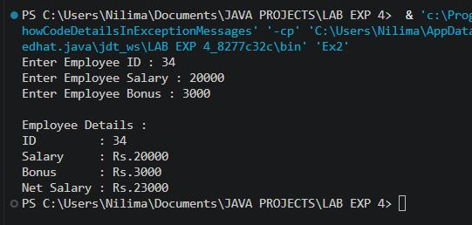
Conclusion | This assignment helped in understanding the concept and importance of Java wrapper classes for converting primitive data types into objects and vice versa. It demonstrated the use of wrapper classes such as Integer, Double, Character, and Boolean for autoboxing, unboxing, parsing, and basic operations on wrapped values. The implementation improved my understanding of data conversion, input  validation, and object-oriented programming concepts. These concepts are widely used in Java.  Collections Framework, file handling, database applications, and other real-world Java programs where object representation of primitive data is required.

